**Mesh plate with hole**

Siva Srinivas Kolukula, PhD

Structural Mechanics Laboratory

IGCAR, Kalpakkam

INDIA [allwayzitzme@gmail.com](mailto:allwayzitzme@gmail.com)

**1. Introduction**

Grid generation is very important in solving partial differential equations in computational fluid dynamics, aerodynamics, tidal and estuary flow, plasma physics, electromagnetic and structures. The generation of grid is the first and foremost step in finite element method, computational fluid dynamics, finite volume method, finite difference method etc. The accuracy of the solution of partial differential equation depends on how fine and sensible is grid for the problem domain. Discretizing the domain is very challenging if the domain is complex. Generating a grid would be easy if analytic expressions are known for the geometries of the domain. Fundamentals of grid generation start with generating a grid when analytic expressions for the domain are known. Readers can refer [1] for this method of grid generation. One of the methods among many other methods of grid generation is by interpolation.

**2. Transfinite Interpolation**

Grid generation based on interpolation has two basic advantages:

1. Rapid computation of grids

2. Direct control over grid point locations

These advantages are offset by the fact that interpolation methods may not generate smooth grids, in particular, when the problem domain has steep curves or bends. In these cases grid gets folded across the bends of the domain. Grid generation methods by interpolation also called algebraic methods. The standard method of algebraic grid generation is known as transfinite interpolation (TFI).

Any 2D grid generation problem demands the description of four boundaries of the region, i.e. four parametric equations for the boundaries.

**X**b(ξ), **X**t(ξ), 0≤ξ≤1,

**X**l(η), **X**r(η), 0≤η≤1 (1)

The subscripts on **X** stand for bottom, top, left and right boundaries of the logical domain as shown in Figure 1. Where **X**i = (x, y)I , it represents it have two components in it.

The vector notation shown in Eq. (1) should be converted to component form to implement in a computer program. There should be four important consistency checks for the boundary formulas at four corners of the region, as shown below.

(i) **X**b(0) = **X**l(0)

(ii) **X**b(1) = **X**r(0)

(iii)**X**r(1) = **X**t(1)

(iv) **X**l(1) = **X**t(0)

1.TIF2.TIF

**Figure 1. Boundaries of Planar region**

The first degree Lagrange polynomials 1-ξ, ξ, 1-η and η are used as blending functions in the basic transfinite interpolation formula. The TFI formula is

**X**(ξ,η) = (1-η)**X**b(ξ) + η**X**t(ξ)+(1-ξ)\***X**l(η)+ξ**X**r(η)

-{ξη**X**t(1)+ξ(1-η)**X**b(1)+η(1-ξ)**X**t(0)+(1-ξ)(1-η)**X**b(0)} (2)

Readers can refer [2] for further method of grid generation using Transfinite interpolation.

**4. Mesh plate with hole using TFI**

In the present section, a plate with hole is meshed using TFI. A plate of length L and breadth, B is considered. In most of the analysis of plates, due to symmetry of the plate a 1/4th grid of the domain is sufficient. Here using 1/4th of the plate is discretized, a hole at the centre of the plate of radius, R is considered. A 1/4th of the plate has five edges. To follow TFI, the domain is divided into two regions of four sides each as shown in Figure 1.

The four boundaries of each domain of the plate are given as follows.

Bottom boundary:

 (1)

 (2)

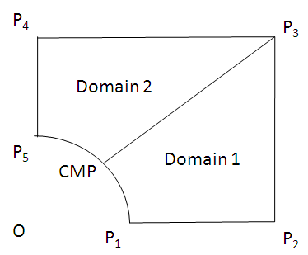

Figure 1: Two domains of 1/4th of the plate with hole

Top boundary:

 (3)

 (4)

Left boundary:

 (5)

 (6)

Right boundary:

 (7)

 (8)

Where in Eqs. (3-8), the subscript 1 stands for domain 1 and subscript 2 stands for domain 2.

A code is written in MATLAB for meshing a plate with hole at center. In the code L, B, R can be varied according to the user. The number of points along ξ and η axes can be varied. A TFI grid of the 1/4th of the plate of length and breadth of 1 unit with hole of radius 0.1 at center is shown in Figure 2. Ten points are taken along the ξ and η axes respectively.

Using these coordinates, the x and y coordinates can be plotted in each quadrant by multiplying these coordinates with the signs in which quadrant they lie in. A grid of full plate with hole at center is shown in Figure 3.

For any discussions, advice, bugs, developing the code please feel free to mail me. Please share your experience with the code by commenting or rating.

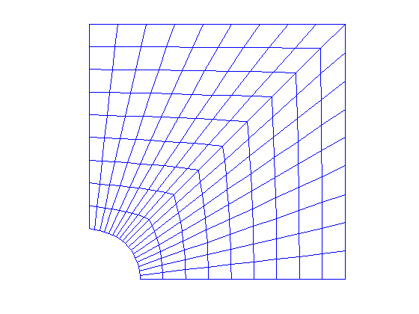

Figure 2: Grid of 1/4th of plate with hole at center

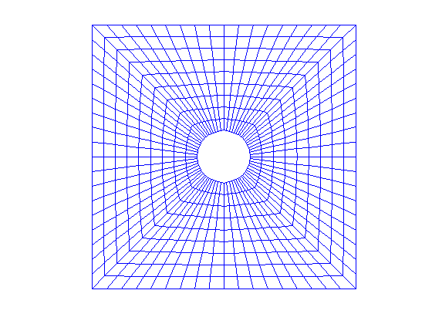

Figure 3: Grid of plate with hole at center

**References:**

[1] Grid generation (To demonstrate grid generation using analytic coordinate systems)

Link: (<http://www.mathworks.in/matlabcentral/fileexchange/40618-grid-generation>)

[2] Transfinite interpolation (To demonstrate grid generation using Transfinite Interpolation)

Link: (<http://www.mathworks.in/matlabcentral/fileexchange/40681-transfinite-interpolation>)